**Summer 2020 - Internship Report**

By: Youssef Samir Sadek – Supervised by Assoc. Prof. Mohammed A-. M. Salem

**Eliminated**

(Action Game)

**Introduction:**

The internship comprises the development of a third person PC action game (Eliminated) using Unreal Engine 4 that spanned over 6 weeks during the period starting from 10th August to 21st August.

**Internship Goal:**

To learn multiple *AI behavior* techniques in Unreal Engine such as:

Sense of:

* Seeing
* Hearing
* Damage receiving

Using Behavior trees, the game AI can make decisions by themselves based on their surroundings and the user actions.

For example, the AI can:

* Respond aggressively to seeing the player
* Investigate sounds made by the users’ weapons, footsteps, and sounds made by firing shots from other AI teammates.
* Sense when they get hit by the user and immediately respond aggressively
* Shoot at the user if the user is within line of sight

**Behavior tree:**

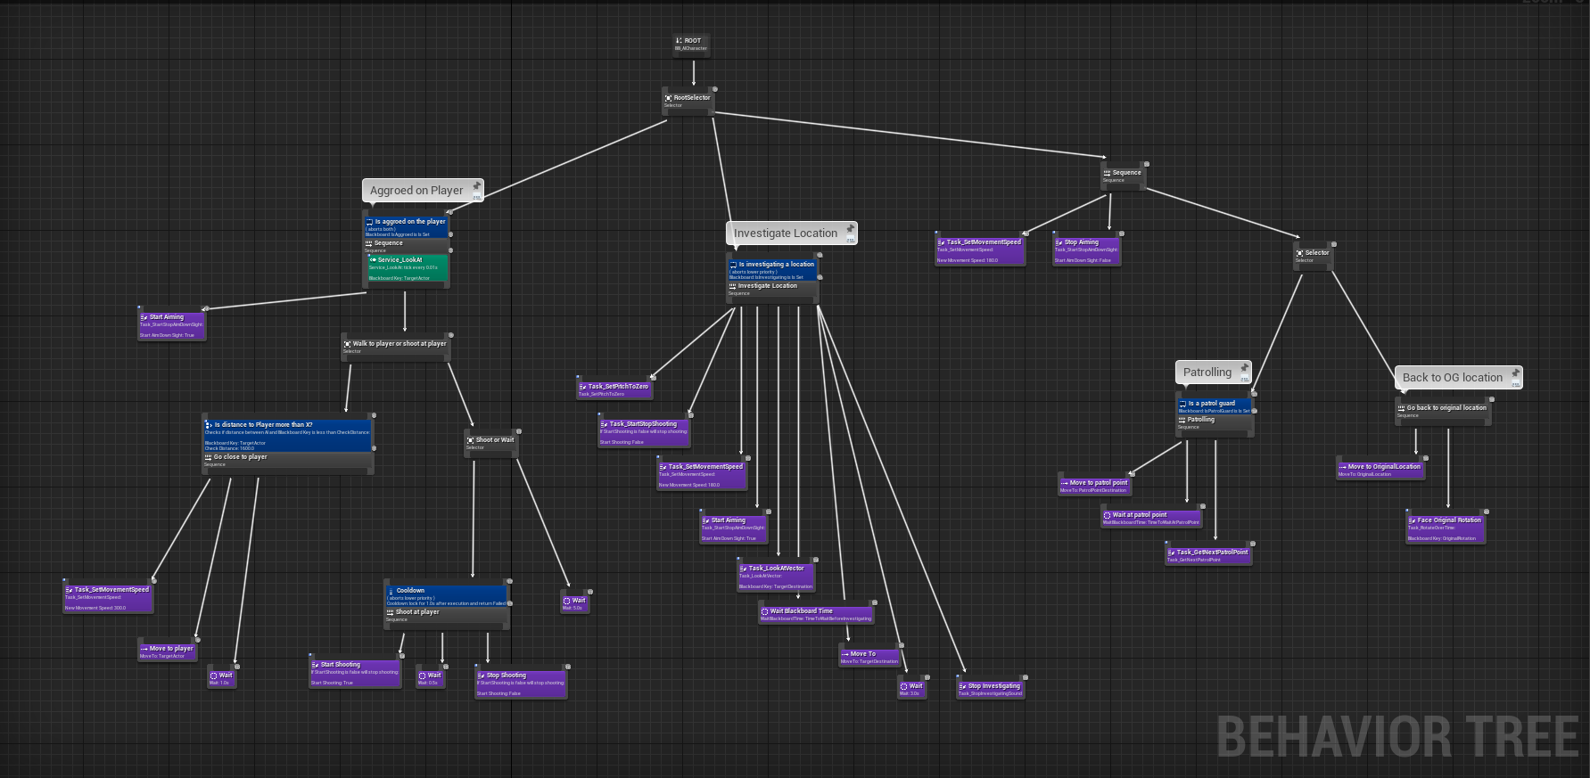

**Map layout:**

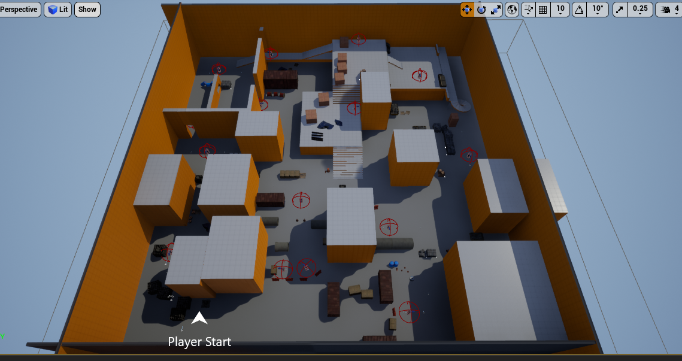

**Mission:**

Your mission is to eliminate everyone!

You can be **stealthy** and knock your enemies out using punches

or your silenced pistol, but be mindful of your limited ammo!

Or go in **loud** using your assault rifle!

**Objective:**

Eliminate everyone without getting killed

**Control Scheme:**

